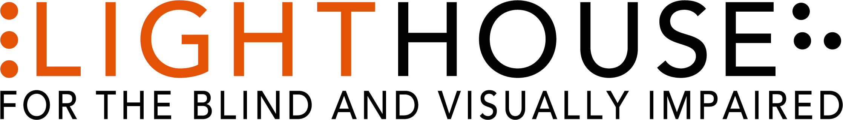

2020 Annual Report
*All data is based on the LightHouse fiscal year: October 1, 2019 – September 30, 2020
Table of Contents for easy reference.
Page 3 – Cover Page with photo
Page 4 – Mission, Vision, Values with photo
Page 5,6 and 7 – Board of Directors, Executive Leadership, Locations
Page 8,9, 10 and 11 – Letter from Board Chair with photo
Page 12, 13 and 14 – Our Programs
Page 15 and 16 – 2020 By the Numbers: Students, Hours, Ages, Program Hours, and Volunteers
Page 17, 18, 19 and 20 – 2020 Outreach: Counties, State and Countries served with State, National, and world map infographics
Page 21, 22, 23 and 24 – EHC By the numbers: Campers, service hours, program
Page 25 and 26 – EHC Camper Profile: Monse
Page 27, 28 and 29 – Holman Prize for Blind Ambition with photos of 2020 winners
Page 30, 31, 32, 33, 34 and 35 – LightHouse Social Enterprises: MADLab, LHI, Adaptations with photos
Page 36, 37, 38 and 39 – Who We Reach: LightHouse in the press, Advocacy groups we worked with, Tech and Accessibility consulting jobs
Page 40 Financial Statements: Assets, Liabilities, Revenue
Page 41 – Photos with captions
Page 42 through 67 – Donor lists
Page 68 – Back Cover with photos and LH contact information.

Serving in unprecedented times;
Pivoting during a pandemic

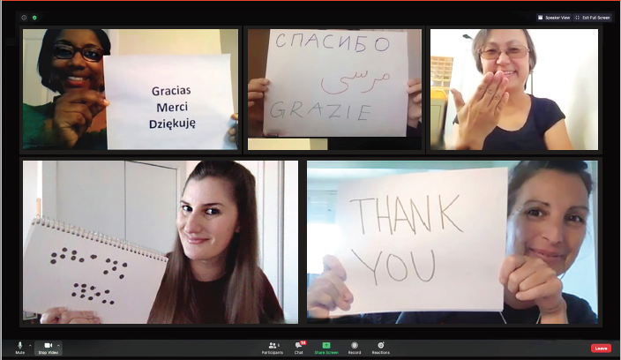

Photo caption: Zoom presentation spelling out “thank you” on cards on a Zoom screen in Spanish, Arabic, French, ASL, braille and English.

MISSION
Founded in 1902, LightHouse for the Blind and Visually Impaired promotes the independence, equality and self-reliance of people who are blind or have low vision.

VISION

We offer blindness skills training and relevant services such as access to employment, education, technology, information, recreation, transportation and the environment. We also pursue the development of new technology, encourage innovation, and amplify the voices of blind individuals around the world.
VALUES
Advocacy, equality, collaboration, employment, literacy, education, innovation, independence, community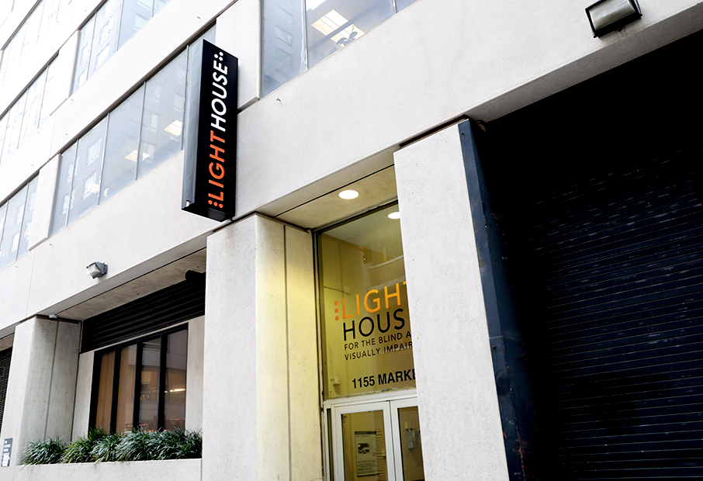

Photo caption: LightHouse building sign with braille “L” and “H”.

BOARD OF DIRECTORS

Sharon Z. Sacks, Ph.D. – Chair

California School for the Blind, Superintendent (retired)

Chris Downey – Immediate Past Chair
Architecture for the Blind, Architect

Luciana Profaca, Ph.D. – First Vice Chair
California Department of Rehabilitation, Chief Deputy (retired)

Joseph Chan – Treasurer, Association of Bay Area Governments, Chief Financial Officer (retired)
Geoffrey Murry – Secretary

Ad Astra – Law Firm, Attorney

Laura Allen – Google, Head of Strategy, Accessibility & Disability Inclusion

Jennison Mark Asuncion – LinkedIn, Head of Accessibility Engineering Evangelism

Janette Barrios – Apple, Accessibility Marketing and Community Manager

Johnny Dadlani – Growing IQ, Managing Partner

Michael Dellar – One Market Restaurant, Co-Founder, Principal
Chancey Fleet – New York Public Library, Assistive Technology Coordinator

Dana Hooper – Life Services Alternatives, Executive Director

Eric Mah – Financial Professional

Michael Nunez, Esq. Rosen Bien Galvan & Grunfeld – LLP, Attorney

Dr. Julius Oatts – UCSF Medical Center, Pediatric Ophthalmologist, Assistant Professor of Ophthalmology

Yue-Ting Siu, TVI/COMS, Ph.D – San Francisco State University,
Assistant Professor

Ahmet Ustunel – San Francisco Unified School District, Teacher of the Visually Impaired

EXECUTIVE LEADERSHIP
Bryan Bashin
CEO

Scott Blanks
Senior Director, Programs

Brandon Cox
Senior Director, Operations

LOCATIONS
LightHouse for the Blind and
Visually Impaired (Headquarters)
San Francisco, CA

LightHouse East Bay,
Ed Roberts Campus
Berkeley, CA

LightHouse North Coast
Eureka, CA

Enchanted Hills Camp for the Blind
Napa, CA

LightHouse Industries
Sirkin Center
Alameda, CA

A letter from our Board Chair Dr. Sharon Sacks
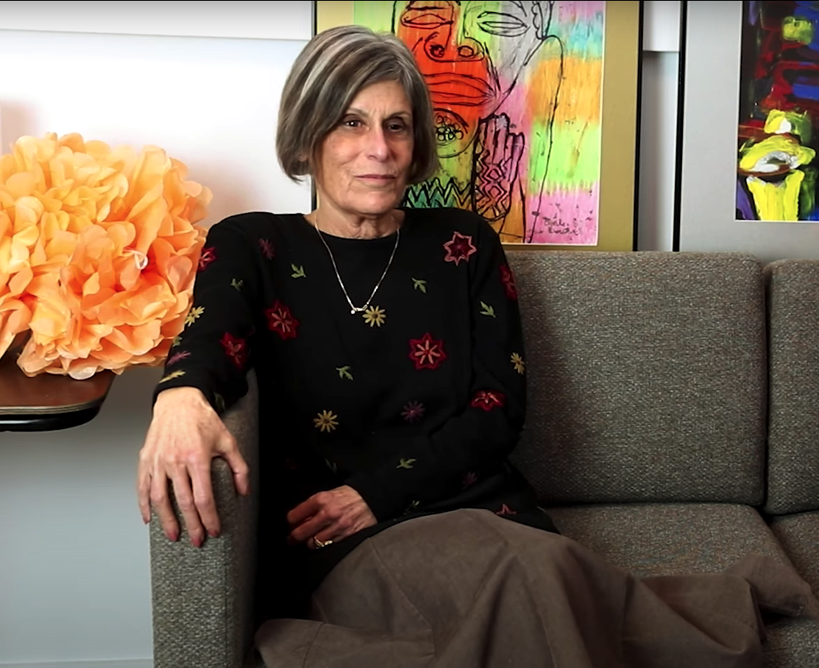

Photo caption: Lighthouse Board Chair Sharon Sacks sits on a couch with paintings behind her.

Dear LightHouse Community,
2020 was an unusual year for everyone around the world. March 13th, 2020 was the last day most LightHouse staff went to work in our offices. As the Board Chair, I am proud to share the LightHouse for the Blind 2020 Annual Report, documenting how LightHouse supported the blind community through a global pandemic, with an engaged, tireless and swift-thinking staff, who for the most part pivoted to do their work from the safety of their homes.

We responded to the new reality with Care Calls. LightHouse staff called 1,277 LightHouse students to offer resources, assess their situations and offer support during an incredibly difficult time. As we began offering all of our classes online, we were surprised by the zealous participation. More seniors participated in ”Coffee with Mike Cole” via Zoom and phone, than had taken part in-person. A new program called “Tech Together” became a huge success, allowing the blind community a place to trouble-shoot tech topics with experts and peers. Braille and tech trainers doubled their teaching hours, as students wanted to become tech-savvy and tactile literate. As the year progressed we saw the need to serve the diversity of the blind community, and we now offer more programs in Spanish than ever before in our 118 years. Because people still need to learn the vital independence skill of traveling with a white cane, our Orientation & Mobility staff began to teach community travel skills in-person, with social distance and masks.

Many of you know me as the previous Superintendent of the California School for the Blind. I myself was born with low vision, and have made a career of improving education for blind children. Kids have had a hard time in the pandemic, and distance education is especially difficult for blind youth. Our Youth Programs coursed in with a host of online support, entertainment, and community to help children & youth isolated at home. Monthly Mentor Mondays helped students learn to advocate for their needs and address misconceptions. “Reel Escape”, a weekend movie club, offered popular films shown with audio descriptions followed by lively conversation. The club “College Spaces from Different Places” created a space for older blind students to connect and support each other.
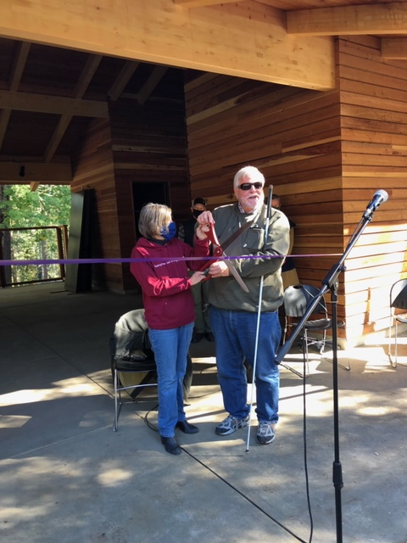
Photo caption: CEO Bryan Bashin and Board Chair Sharon Sacks cut the ribbon for our new pool house opening at EHC.

It was Enchanted Hills Camp’s 70th Anniversary of providing a community of growth for blind campers. With virtual campfires, a series of Facebook Live concerts and camp sessions held via Zoom, EHC provided a vital connection for blind campers, throughout the year. Meanwhile, the camp renewal continues. The legacy buildings received handsome, fireproof metal roofs and new deep green paint to harmonize with the plush green landscape. The pool has a new fence and pool house, resplendent with a guide dog shade area and clad in redwood salvaged from trees lost in the fires. Meanwhile, in 2020 we planned for a total re-envisioning of Enchanted Hills as a global center for blindness training in the summer and beyond, with construction planned over the coming 24 months.

In 2020, big things happened at the Sirkin Center, LightHouse’s blind labor-force manufacturing plant. We had just recently added a line of cleaners and disinfectants to the production at Sirkin. Then it became clear that our hard surface cleaner was effective at killing the novel coronavirus. Suddenly our burgeoning new business went prime time. We were able to double our staff and hire a blind scientist to oversee the product blends. Our customer base of government agencies and private companies continues to grow, and so do the employment opportunities for people who are blind or have low vision. The BBC covered Sirkin Center’s unprecedented growth in this video.

LightHouse’s Madlab creates innovative tactile and accessible materials. They partnered with the New York Library to provide our unique TMAPS for patrons. These tactile maps are empowering library patrons to understand the streetscape in NYC and beyond. TMAPs can be ordered for any location through Adaptations, LightHouse’s store. While our staff miss the hands-on approach in the store, Adaptations is now fully online, serving customers all over the globe.

The three 2019 Holman prize for blind ambition winners, Mona Minkara (created travel documentaries about public transit around the world), Alieu Jaiteh (provided training for blind adults in rural Gambia) and Yuma Decaux (created an app for blind citizen scientists to explore space acoustically) completed their Holman year with a bit of an extension due to COVID. Meanwhile Tyler Merren (pioneering an app for fitness for people who are blind or have low vision), Dr. Birendra Raj Sharma Pokharel (training blind women in Nepal in early detection of breast cancer) and Tiffany Brar (providing blind empowerment and skills to blind youth in South India) began their adventures and projects, all focused on bettering the world.

Looking ahead, I foresee a future of LightHouse programs held in-person with segments taught virtually. Lessons learned during this challenging time will make our programs more effective and accessible to greater numbers of blind students in the years to come.

Thank you for being part of our LightHouse family. In these difficult times, your support is essential to our success.

Best wishes,
Sharon Zell Sacks, Ph.D.LightHouse Board Chair

OUR PROGRAMS

ACCESS TECHNOLOGY - The Access Technology department facilitates the use of accessible technology among people of all ages and levels of expertise. We also work with companies on design consulting, functional accessibility review and user testing sessions.

ADAPTATIONS STORE - Located on the 10th Floor of our San Francisco headquarters, as well as online, Adaptations is the only place in Northern California with a comprehensive offering of tools, technology and other solutions used by
blind people.

BLIND AND LOW VISION SKILLS – Training in low vision and blindness skills, including Orientation and Mobility, braille, pre-guide dog skills in partnership with Guide Dogs for the Blind, and independent living skills curriculum like Changing Vision, Changing Life, our flagship introductory program to those with changing vision who want an intensive introduction to the myriad options available at LightHouse.

COMMUNITY SERVICES – Blind adults come together in-person and virtually for social events, professional mentoring, accessible movie nights, museum tours, crafting, cooking and fitness programs.

COUNSELING SERVICES – Available in individual, couples and
group settings, LightHouse counseling services support a student’s
overall well-being.

DEAF-BLIND SERVICES – Deaf-blind students benefit from training, resources and free technology. In 2020, LightHouse supplied Deaf-blind students with 450 pieces of equipment valued at $268,008.

EMPLOYMENT IMMERSION – Blind and low vision jobseekers receive personalized training to learn how to identify job openings, network, interview and secure competitive employment. More than 100 graduates have secured employment since the program began in 2011.

ENCHANTED HILLS CAMP AND RETREAT – The oldest camp for the blind in the American West, hosting campers since 1950. This year we went virtual, hosting four different remote camp sessions and remote campfires to thousands of viewers all over the world.

LIGHTHOUSE INDUSTRIES SIRKING CENTRE – Our state-of-the-art manufacturing center produces essential disinfectants and cleaning products in the fight against COVID. Over 80% of employees at LightHouse Sirkin Center are blind or have low vision, working in all aspects of our business from the production line to quality assurance to the new product development laboratory.

LIGHTHOUSE LABS – A think-tank for technologists, corporations and designers to meet regularly with blind scientists, engineers and savvy consumers.

MEDIA AND ACCESSIBLE DESIGN LAB (MAD Lab) – This team of designers produces tactile graphics, maps, 3D educational objects, ADA signage, braille
and more.

THE JOSEPH CHAN LOW VISION OPTOMETRY CLINIC – In partnership with the UC Berkeley School of Optometry and located within LightHouse Headquarters, this is a low vision and primary care eye clinic.

VOLUNTEER SERVICES – Throughout the COVID-19 pandemic, volunteers continue to meet with blind community members requesting volunteer matches, students one-on-one, both virtually and through essential in-person visits, as well as providing LightHouse administrative support and maintaining Enchanted Hills Camp.

YOUTH PROGRAMS – LightHouse offers activities for blind and low vision youth, including STEM education, outdoor adventures and a monthly YES Academy, a mentor-led employment series that encourages blind teens to prepare for professional success.

2020 Impact by the Numbers
Blind students served: 1,624
Teaching hours: 24,390
Care Calls During Covid: 1,277

Ages:
65+: 623
25-64: 794
19-24: 105
13-18: 85
0-12: 12
Program hours:
Adults and Seniors: 3,972
Youth: 3,221
Orientation and Mobility: 3,767
Braille: 899
Psychological Services and Counseling: 514
Blind and Low Vision Skills: 875
Employment Immersion: 2,755
Student Support: 1,777
Access Technology: 3,851
Deaf-Blind: 1,581
Grand Total: 24,390 hours

Volunteer Programs
Total Volunteer Hours: 8,326
Total Number of Volunteers: 242 people
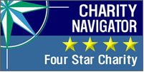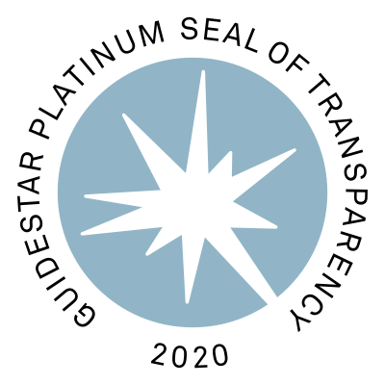
Four-Star Charity Navigator and Platinum GuideStar logos above

2020 Outreach California
LightHouse reaches a robust network of students and organizations at state, national and international levels. In 2020, LightHouse served 45 California Counties.
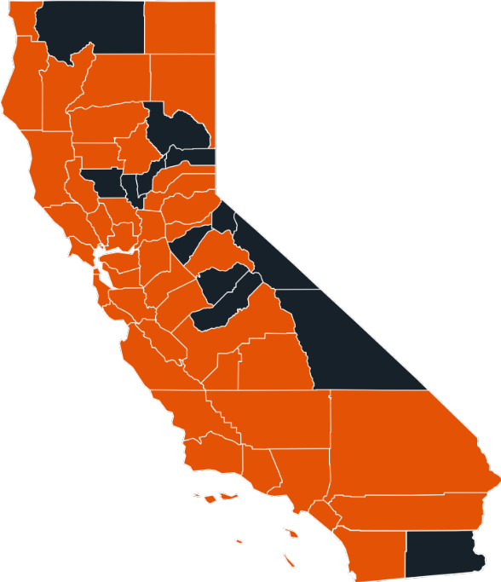
Photo caption: Map of the State of California Infographic

Counties Served:
Alameda
Amador
Butte
Calaveras
Contra Costa
Del Norte
El Dorado
Fresno
Glenn
Humboldt
Kern
Kings
Lake
Lassen
Los Angeles
Marin
Mendocino
Merced
Modoc
Monterey
Napa
Nevada
Orange
Placer
Riverside
Sacramento
San Benito
San Bernardino
San Diego
San Francisco
San Joaquin
San Luis Obispo
San Mateo
Santa Barbara
Santa Clara
Santa Cruz
Shasta
Solano
Sonoma
Stanislaus
Tehama
Trinity
Tulare
Tuolumne
Yolo

2020 National and International Outreach

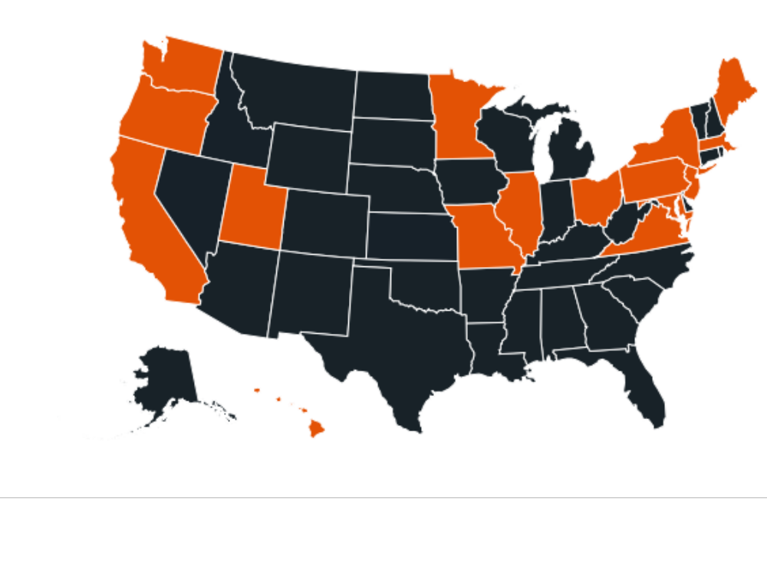
Photo caption: Map of nation infographic

In 2020, LightHouse served students from 17 states:
California, District of Colombia, Hawaii, Illinois, Maryland, Massachusetts, Maine, Minnesota, Missouri, New Jersey, New York, Ohio, Oregon, Pennsylvania, Utah, Virginia, and Washington.
Highlights from our Student Surveys
- 90% students say they would refer someone to LightHouse.
- 88% students say that LightHouse was useful and relevant in meeting their interests and needs.
- 90% students found LightHouse staff to be professional
and knowledgeable.

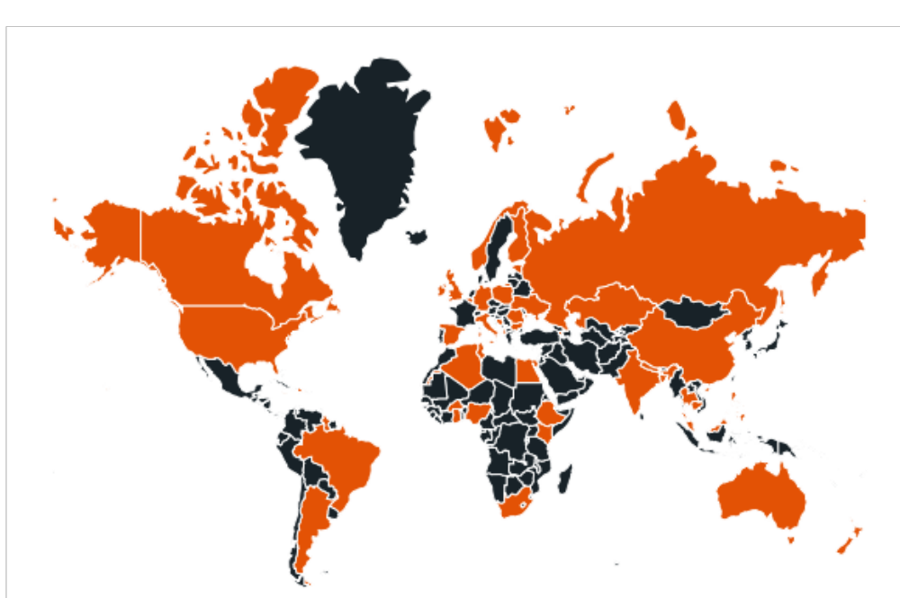
Photo caption: Infographic map of the world
Thanks to our Holman Prize and a large international contingent at camp, our international network continues to expand. In 2020, LightHouse reached these countries.
Albania
Algeria
Armenia
Australia
Bangladesh
Bosnia and Herzegovina
Brazil
Burkina Faso
Canada
China
Estonia
Finland
Gambia
Germany
Ghana
Holland
India
Ireland
Italy
Kazakhstan
Kenya
New Zealand
Malaysia
Nepal
Nigeria
Philippines
Poland
Romania
Russia
Spain
United Kingdom
United States
Zimbabwe

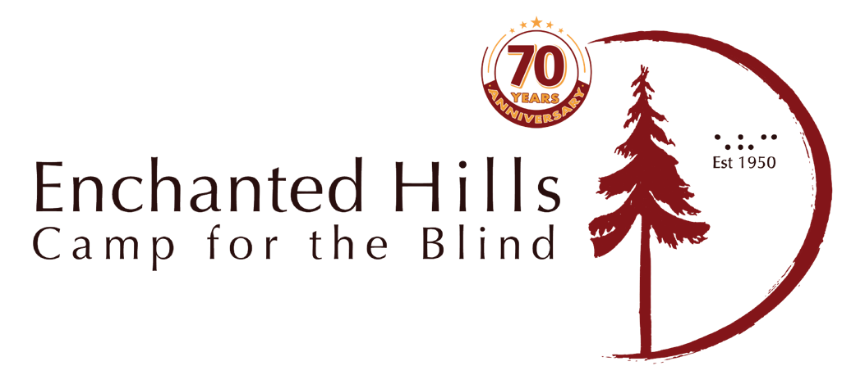
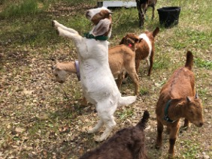

Photo caption: Our new goats! White goat standing on its hind legs.

2020 was our 70th year of EHC, but we were not able to be together in person due to the pandemic. We ran these programs remotely:
- EHC hosted ten different virtual summer sessions in 2020.
- Music Camp rocked the world with a virtual concert finale for several thousand audience members through Facebook Live.
- EHC sponsored a series of ten online music concerts featuring professional musicians, many of whom were previous EHC campers or employees. This event was well attended with over 32,000 reactions from people from all over the world.
- EHC hosted virtual campfire sessions attended by campers from all over the world.
- The new poolhouse is complete, clad in redwood lumber milled from trees damaged in the 2017 fire.
- Two AmeriCorps groups spent six weeks working on a variety of projects: rebuilding bridges and fences, maintaining trails, and helping keep camp in shape.
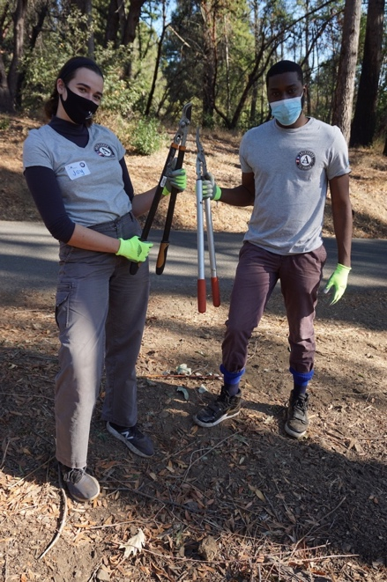

Photo caption: Two EHC AmeriCorps volunteers holding clippers.

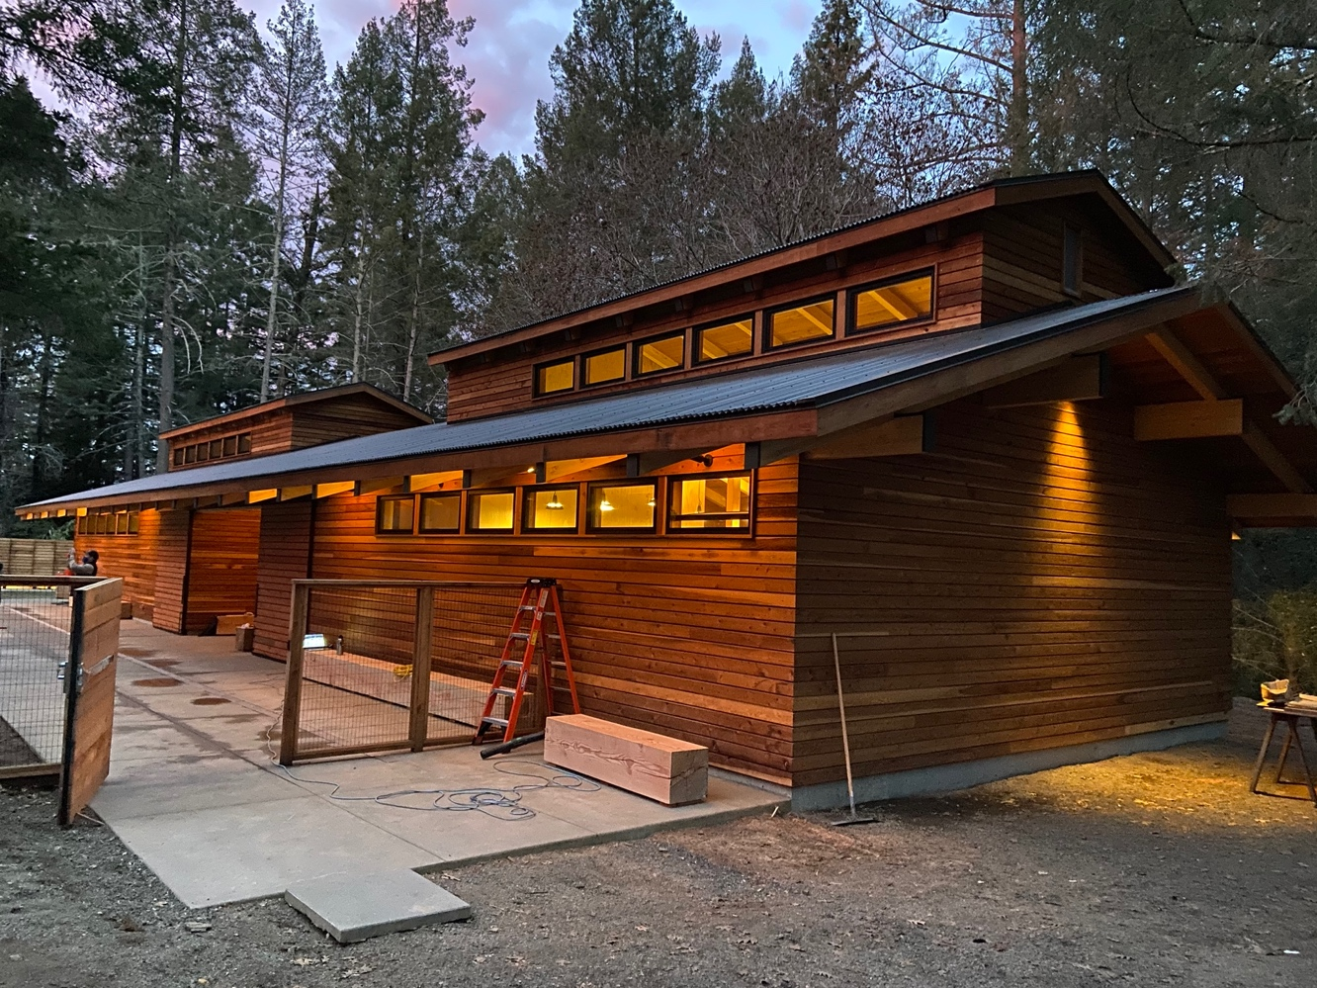

Photo caption: New poolhouse at EHC.
EHC by the Numbers 2020
Blind Campers: 155
Camper hours: 1,485
EHC Virtual Holiday Concert audience: 2,200
Total reach for EHC concert series on Facebook Live and virtual campfire sessions: 32,000
EHC 2020 Virtual Programs
Adult Session
Youth Camp
Teen Camp
Music Camp
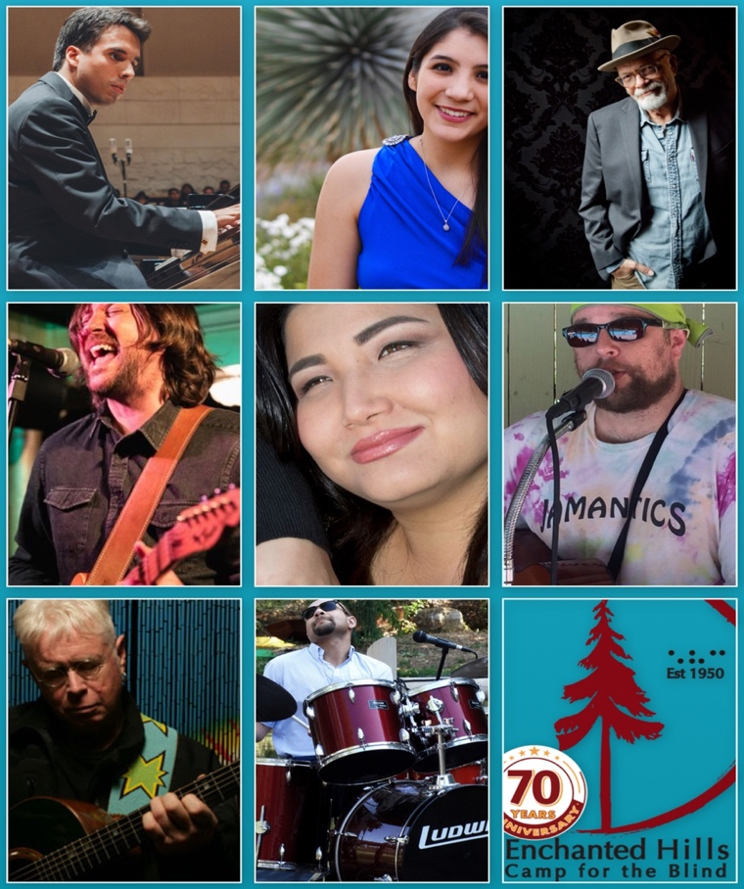
Photo caption reading Left to right: Grid of performers’ headshots from the summer “Give Back Concert Series.” Fernando Apan, Mariana Sandoval, Phil Madera, Graham Norwood, Christina Jones, Maceo Williams, Bruce Cockburn, Lawrence Brown and the EHC 70th Anniversary Logo.

EHC Camper Profile

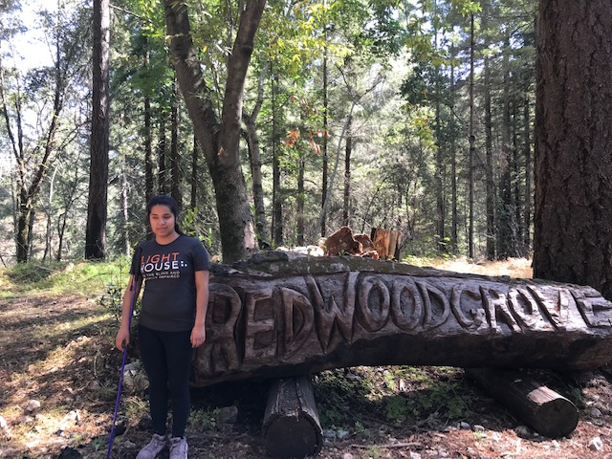

Photo caption: EHC camper Monse stands in front of the Redwood Grove sign, carved from a felled redwood tree.
Meet Monse, a blind 16-year-old student, currently in her junior year of high school in California. A few years ago, Monse attended Enchanted Hills Camp for the Blind with her family. Like many parents, Monse’s were hesitant about sending their blind kid away from home. At Family Camp they witnessed how their daughter thrived in an environment where being blind was just another part of her life.

The following July, Monse returned on her own for the Youth Session, and ever since, Enchanted Hills had become her eagerly awaited summer experience.

Until the pandemic scotched our summer 2020 sessions, Monse was planning on attending the two-week session for teens and looked forward to the special formal dinner and dance, the kayaking field trip and the karate workshop.

When the 2020 camp session was cancelled, Monse was sad, but she discovered that all was not lost. Monse was able to join her friends online for the virtual Teen Session. There were games and sing-alongs at the campfire, but what has really stayed with Monse are the profound conversations.

She told us, “We had deep discussions on blindness, the challenges of transitioning from high school to college and how to advocate for ourselves. We also covered strategies for overcoming the isolation and loneliness of the pandemic.” These are conversations that blind kids just don’t have anywhere else.

In addition to friendship and outdoor exploration, Enchanted Hills provides opportunities for older campers to flex their leadership muscles and gain responsibility. Almost all of our counselors are blind, many of whom have worked their way up from campers, to Counselors in Training (CITs), to paid employees. This summer Monse took part in the CIT program. Camp Director Tony Fletcher enthused, “Monse is a promising up-and-comer at Enchanted Hills. I see a bright future for her on our staff.”

Despite challenges, LightHouse was able to hold 2020 summer camp sessions online, including Music Camp, STEM programs, sessions for blind adults, plus some amazing community concerts and campfires. Enchanted Hills Camp is provided free to blind kids, many of whom are from low-income families.

2020 was the 70th anniversary year of the birth of our beloved camp, a sanctuary and place to learn self-reliance for 30,000 campers and growing. We are now re-imagining Enchanted Hills and will soon build 20 new cabins and program areas.

Holman Prize for Blind Ambition
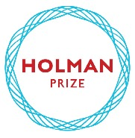

Now in its fifth year, LightHouse’s Holman Prize for Blind Ambition is an international competition with a monetary prize that is awarded annually to three blind individuals who wish to push their limits. It is named for James Holman, a nineteenth-century blind explorer and author, who was the most prolific private traveler before the era of modern transportation.
In 2017, LightHouse for the Blind launched the Holman Prize to support the emerging adventurousness and can-do spirit of blind and low vision people worldwide. This endeavor celebrates people who want to shape their own futures instead of having them laid out for them. Created specifically for legally blind individuals with a penchant for exploration of all types, the annual Holman Prize for Blind Ambition provides financial backing – up to $25,000 – for three individuals to explore the world and push their limits.
The ideal candidate is someone who is willing to probe their environment and eager to savor the richness of a world that is so often thought of as inaccessible to the blind. Prize winners embark on adventures of their choosing, which may involve travel, community organizing, athletics, scientific exploration, art and more. In addition to motivating blind individuals to realize their dreams, the purpose of the Holman Prize is to change the world’s perception of blind ability.

2020 Holman Prize Recipients

Tiffany Brar, India:
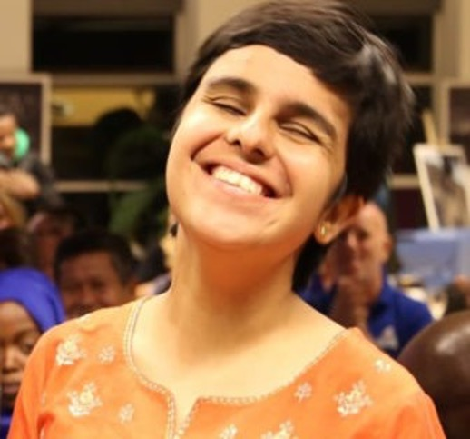
Photo caption: Close up of Tiffany Brar smiling.
Brar’s Holman ambition is called “Reaching the Unreached.” With the Holman Prize, Brar will expand services for the blind into rural and tribal south India. Brar’s goal is to train more than 300 blind people across four states: Kerala, Tamil Nadu, Telangana, and Karnataka. She hopes to help teenagers enroll in school and adults participate in residential training centers for the blind or find jobs.
Tyler Merren, USA:
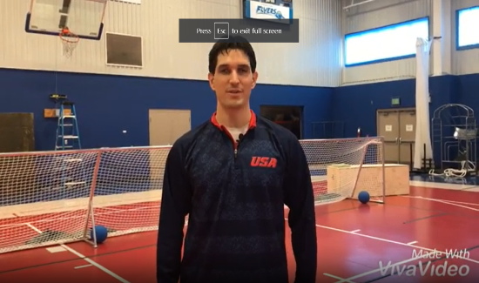
Photo caption: Close up of Tyler Merren.
Tyler Merren will develop “ReVision Fitness”, an audio-based fitness mobile application. “While there are many fitness apps out there,” said Merren, “they don’t provide an adequate description of exercises for people who are blind.” The app will include descriptions of equipment, nutrition, heart rate monitoring and journal capabilities, all in an accessible format.
Dr. Raj Sharma Pokharel, Nepal:
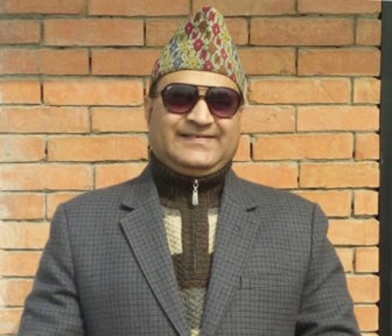
Photo caption: Close up of Dr. Sharma Pokharel.
Dr. Pokharel will use his Holman Prize funds to provide training for blind women in Nepal to become Medical Tactile Examiners in the early detection of breast cancer. The new program will provide an employment path for up to 30 blind Nepalese women who traditionally face enormous barriers to employment.

To learn more about the prize and its winners, view our short video:
https://www.youtube.com/watch?v=b2ofhVRjzvA&t

LIGHTHOUSE SOCIAL ENTERPRISES

MEDIA AND ACCESSIBLE DESIGN LAB (MAD Lab)
From printed information to physical space, our MAD Lab specializes in making the visual tactile and turning inaccessible experiences into inclusive ones. Our team of designers and consultants works to enhance understanding of what images and diagrams can do for blind people. We believe that equitable access to information should be an ordinary experience, and that image poverty is avoidable. So we make things that are aesthetically pleasing, legible, relevant and meaningful to blind people. With enough images under our fingertips, image fluency, perceptual and creative abilities around spatial information can flourish.

MAD Lab 2020 Year in Review
Architectural Signage: The San Francisco Mayor’s Office on Disability and San Francisco Public Works require City projects to obtain a letter from LightHouse certifying that all tactile signs with raised characters and braille comply with building code signage standards. By providing this essential service, MAD Lab allows public housing and other public building projects to go forward.
TMAP: During COVID, there has been an exigency among teachers and students around long-term distance learning. In response, MAD Lab and LightHouse’s Orientation and Mobility instructors partnered on a series of webinars that show how indispensable TMAPs are at giving people everyday access to spatial information. As TMAP is incorporated into Orientation and Mobility lessons we’re witnessing a profound change in how practitioners think about and use tactile graphics.
Interpretive exhibits: Visitors can run their fingers along MAD Lab designed braille and tactile exhibits at parks and museums including Ala Kahakai National Historic Trail, Asian Art Museum, CIA, de Young Museum, Disney, Exploratorium, Fremont Museum, Golden Gate National Recreation Area, John Dickinson Plantation, National Library Service, Oakland Museum of California, Patterson Great Falls National Historic Park, SOMArts Cultural Center and Utah State Parks.
Master Plan for Re-imagining of Enchanted Hills Camp: MAD Lab supplies blind people on the EHC Visioning Committee and our Board of Directors with the accessible materials, maps, and plans for the new EHC.

MAD Lab by the Numbers
316 different projects for 78 customers in 17 states (CA, DC, HI, IL, MA, MD, ME, MN, MS, NJ, NY, OH, OR, PA, UT, VA, WA). Customers include ACLU, Amazon, Apple, CIA, Disney, Facebook, Federal Reserve, Google, Maximus, NFB, National Library Service for the Blind and Print Disabled at the Library of Congress, National Park Service, Partnership HealthPlan of California, PG&E, Salesforce, Siemens Mobility, Stanford University, Sutter Health, Verizon Media and Volkswagen Group.
Total Projects by MAD Lab 2020 – 369 projects broken down into the following categories:
Accessible Design: consulting, tactile maps, graphics, 3D – 61 projects
Architectural Signage Inspection and Certification – 27 approval letters certifying 2,968 signs as 2010 ADA & 2019 CBC compliant
Braille Translation – 21,786 pages
Braille Business Cards – 5,162 cards
Audio Recordings – 20 recordings
Training, Workshops, Presentations, and Interviews – 19 with over 1606 attendees and 244 YouTube views
TMAPs distributed by MAD Lab – 1,561
Non-Lighthouse distributed TMAPs (TMAP users and downloads) – 109 users downloaded 247 maps
MAD Lab products sold through Adaptations – With 61 products in the Adaptations store catalog, 569 items made it into 200 customers’ hands
MAD Lab Map List – 613 subscribers
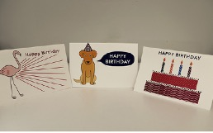
Photo caption: Three birthday cards, one with a flamingo, one with a dog in a birthday hat, and the third showing a birthday cake with Happy Birthday written in text and braille.
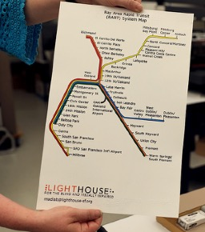
Photo caption: A TMAP showing the Bay Area Rapid Transit (BART) System Map with LightHouse logo on the bottom.

ADAPTATIONS BLIND TECHNOLOGY STORE

Adaptations is the only place in Northern California with a comprehensive offering of tools, technology, and other
solutions for blind and people who have low vision.
2020 Statistics
Total number of items sold: 5,257
Total number of transactions: 1,849
Total number of unique customers: 1,235
Number of visitors to Adaptations.org since its launch: 15,185
Total number of online orders: 487

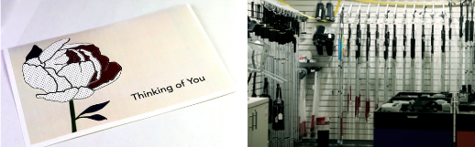
Photo captions:
Image 1 – Card with a flower with “Thinking of You” in text and braille.
Image 2 – White canes hung on the wall in the Adaptations store.

THE SIRKIN CENTER
For decades, The Sirkin Center has provided employment for people who are blind. These jobs include customer service, shipping and receiving, inventory management and light manufacturing – making tissue packets which are included in MREs (Meals Ready to Eat) in emergency rations utilized by soldiers, rescue workers and firefighters in the field.
Recently Sirkin Center expanded the business to include the production of EPA Safer Choice PRIDEClean cleaning and disinfectant products. This is a line of non-toxic, green cleaning products used at private and public facilities around the country. The products contain no ammonia, phosphates, are biodegradable and contain zero to low VOCs. The Sirkin Center also produces Skilcraft Glass and All-Purpose Cleaners and Pure Bioscience Hard Surface Disinfectants in partnership with National Industries for the Blind and the Ability One Commission. PURE Hard Surface Cleaner contains no bleach, ammonia, phosphates, phenols or VOC emitting compounds through an odorless formula that is non-caustic and non-irritating. In 2020, PURE was added to the EPA’s List N as a product that is effective against COVID-19.
The Sirkin Center is one of LightHouse’s initiatives dedicated to the employment of people who are blind. By the end of 2021 we expect that 30 blind people will be on payroll at the Sirkin Center. Blind employees hold a variety of positions including a scientist hired in 2020 to oversee our quality control program. In an unprecedented year, Sirkin Center has greatly increased our customer base, productivity and support for LightHouse programs.
Packets of tissue produced in 2020: 51,000,000
Line filled bottling in 2020: 600,000 units
85 percent of the direct labor in our facility comes from blind employees. We doubled our employees from 10 to 21 employees.
 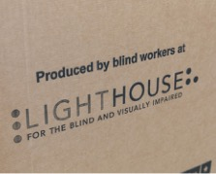
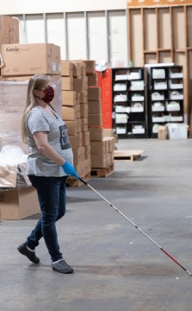 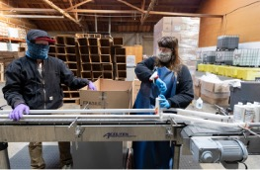

Photo captions: Image 1 – Masked LightHouse Production Assistant Valentino Benelli bottles cleaning product at Sirkin Center. Image 2 – A cardboard box used to ship product, labeled with the words “Produced by blind workers at LightHouse for the Blind and Visually Impaired.” Image 3 – A view of masked Production Assistants Jennifer Holloway with Valentino Benelli bottling cleaning product at Sirkin Center. Image 4 – One thousand-pound rolls of toilet paper await repackaging at the Sirkin Center in San Leandro. Image 5 – Masked LightHouse Production Assistant Rebecca Reinier walks across the warehouse floor of Sirkin Center with a white cane.

Who We Reach
Part of LightHouse’s mission is to communicate the truth about blindness to the widest possible audience. These prominent media sources published articles about LightHouse in 2020.
60 Minutes
Board Member, Chris Downey and LightHouse were featured again on 60 Minutes

BBC Radio In Touch
Listen to 2019 Holman Prizewinner: Mona Minkara On Her Global Public Transport Experiences.

BBC World Service
Watch this BBC World News report about how LightHouse Industries staff who are blind and have low vision are providing essential products to help fight COVID-19 during the pandemic.

San Francisco Chronicle
LightHouse Industries photo essay.On the bright side: Blind workers on a roll making toilet paper at San Leandro factory

Sight Tech News
Accessibility from the wheels up: the Waymo self driving taxi

Vice News
Vital Coronavirus Information Is Failing the Blind and Visually Impaired

The Napa Valley Register
COVID-19 concerns cancel Napa summer camp for blind students

NBC Bay Area
NBC Bay Area Visits 2019 Project Innovation Recipient

ADVOCACY

In 2020 we worked with advocacy groups, companies and organizations from across the nation.
AbilityOne
AER
American Camp Association (ACA)
American Foundation for the Blind
American Printing House for the Blind
American Red Cross
Americorps NCCC
Bay Area Arts Access Collective
Better Market Street Coalition
Blindness Support Services in Riverside
Braille Institute of America
CCBVI, Stockton
California Able Act Board
California Blind Advisory Committee
California Council of the Blind
California Department of Rehabilitation
Canadian National Institute of the Blind (CNIB)
Center of Vision Enhancement
City and County of San Francisco
Cruise Automation
Dayle McIntosh Center
Department of Veterans Affairs
Disability Rights Advocates
Earle Baum Center
Foundation for Independent Living Centers
Mid-Market Community Benefit District
Mt. Veeder Fire Safety Council
Napa Open Space District
Napa Resource Conservation District
National Association of Blind Students
National Federation of the Blind
National Federation of the Blind of California
NIB
Nicole Lee Consulting
Northern California Association of Orientation & Mobility Specialists (NCAOMS)
Northern California Deaf-Blind Association
Pride Industries
San Francisco’s Mayor’s Office on Disability
San Francisco State University Teachers of the Visually Impaired and Orientation and Mobility Departments
SF Tech Council
Senior & Disability Action
SF Public Utilities Commission
TRE Legal Services
United States Association of Blind Athletes
VisionServe Alliance
Vision Zero- Safe Streets
Vista Center for the Blind
Waymo
World According to Sound
World Blind Union
World Institute on Disability

ACCESSIBILITY
We consulted and worked on tech and accessibility with companies all over the world, including:
Amazon
AnswerLab
Automattic Inc.
Blackbird Studios
Google LLC
Level Access
LinkedIn
McGraw-Hill Higher Education
NEST
Volkswagen Group

2020 Financials

Support and Revenue:
Government Contracts and other grants: $1,497,692
Donations and Bequests: $1,484,537
Sales: $4,958,504
Fees for Service: $1,085,849
Interest and Dividends: $2,956,924
Insurance Reimbursements: $593,677
Other Revenue: $385,609
Total Support and Revenue: $12,962,792
Operating Expenses:
Program Services: $14,064,280
General and Administration: $2,992,180
Fundraising: $1,276,581
Total Expenses: $18,333,041

Change in Net Assets from Operations: $5,370,249

Other Gains and Losses:
Realized and Unrealized Gains (Losses) on Investments, net of fees: $4,677,398
Change in Value of Interest Rate Swap: ($604,376)
Change in Net Assets: ($1,297,227)

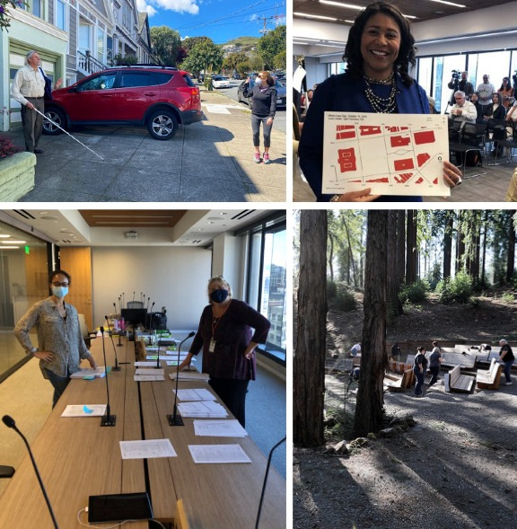

Photo captions left to right:
Image 1 – Former Board member Jerry Kuns holds a white cane and waves to Development Director Jennifer Sachs, who is wearing a mask.
Image 2 – San Francisco Mayor London Breed holds up a TMAP of the Civic Center that she received on White Cane Day, 2019 at the LightHouse.
Image 3 – Kathy Abrahamson, Director of Rehabilitative Services, stands with Alyah Thomas, Administrative Assistant EHC/Deaf-Blind, in the conference room at LightHouse. Both are wearing masks.
Image 4 – Campers sit in Redwood Amphitheater at EHC, behind two redwood trees in 2019.

LIGHTHOUSE DONORS
LightHouse is grateful to our thousands of donors who, for 118 years, have made it possible to meet our community’s needs.
We couldn’t do our work without you.
Note: Members of our monthly giving program, the Compass Club, are marked by an asterisk.

$100,000+

COMPANIES,
CORPORATIONS AND
FOUNDATIONS
North Loop 3, LLC

$50,000 – 99,999

COMPANIES,
CORPORATIONS AND
FOUNDATIONS
Consumer Technology Association
Foundation

$35,000 - $50,000

INDIVIDUALS
Inez E. Martini

COMPANIES,
CORPORATIONS AND
FOUNDATIONS
American Honda Foundation
Comcast

$25,000 – 34,999

COMPANIES,
CORPORATIONS AND
FOUNDATIONS
Mr. and Mrs. G. Kirk Swingle Foundation
Schwab Charitable
Uber Technologies

$10,000 - $24,999

INDIVIDUALS
Ronald and Lois Bloom
Ken and Jennifer Bunt
Nancy Foss
Fred Ruhland
Charles and Elizabeth Travers
John Wilhelm and Tora Isi

COMPANIES,
CORPORATIONS AND
FOUNDATIONS
Charitable Adult Rides & Services,
Inc. (CARs)
Delong-Sweet Family Foundation
Delta Gamma Foundation
Dodge & Cox Investment Managers
Facebook
First Dollar Foundation
Hobson/Lucas Family Foundation
JS & S Michaan Foundation
National Endowment for the Arts
Pacific Gas and Electric Company
Polara Enterprises, LLC
Syar Foundation
The Annunziata Sanguinetti Foundation
The Benevity Community Impact Fund
The Travers Family Foundation
The Walt Disney Company Foundation

$1,000 - $9,999

INDIVIDUALS
Edward Adams
Ginger and Don Anderson
Sweta Arora
Jennison Asuncion
Judy Barrett
Douglas E. Bergman*
Marilyn Brown
Marie Anne Burkhard
Sandy Cademartori
Lisa Carvalho and David Mager
Joseph Chan*
Horng-Yee Chou
Laura Cinquini
Robert and Pamela Clark
Michael and Leslye Dellar
Kirk and Tamara Dittmar
Joyce M. Dubay
Barbara Eddy
Signe Erickson
Marjorie Follette
Jonathan Funk
Claire Gaudiani and David Burnett
Martha Girdlestone
Candice and Jesse Gomez
Zarah Gulamhusein
Patricia and Greg Gump
Vivian Guze
Gena Harper
Nancy K. Hayes
Eugenia H. Haynie
Mr. and Mrs. Richard Hesse
Judy Howard Giles and Ray Giles
Randolph James
Dwight Johnson
Ronald and Susan Kahn
Mr. and Mrs. Komala Kailash
Andrew Kebbel
Roberta Kehret
Shawn Klein
Nancy Ku and Thomas Wei
Jerry A. Kuns
Elizabeth Laflamme
Barbara J. Lassen
Paul and Jerrie Lore
Peter Lovecchio
Eric and Jacalyn Mah
Michael F. Marmor, M.D.
Karen Meryash
Jane and Robert Micks
Tarak Mody and the Mody Family
Geoffrey Murry
Timothy Ng
Margaret Niland
Bill Norton
Michael Nunez
Paul Park
Rachel Perkins
Luciana Profaca
Sharon and Richard Sacks
Rachel Sanders
Richard and Monica Schoenberger
Seema Shams
Michael and Carole Shebanek
Moira Shek
Diane and Howard Slater
Marc Sola
The Stadlin Family
Richard Stevens and Virginia Behm
Noemi Rebeli Szabo
Timothy Teske
Vrishali Thorat
Patti Birge Tyson
Marco A. Vidal Fund
Carmen Rose Wayson
David and Regula Weill
Daniel Willhite
Henry and Sandra Wong
Bonnie and David Young
Jacqueline Young

COMPANIES,
CORPORATIONS AND
FOUNDATIONS
Alice Phelan Sullivan Corporation
America’s Best Local Charities
Apple, Inc.
Asymmetric Publications
Blaisdell’s Business Products
Bright Funds Foundation
Business Links, Inc.
Charles Schwab Corp
Chateau Montelena Winery
Coach, Inc.
Community Projects, Inc.
Dean & Margaret Lesher Foundation
Ed & Betty Manoyan Foundation
Equinix
Fidelity Charitable Gift Fund
Fitness SF
Goodwin Family Memorial Trust
Handiworks
Herbst Foundation, Inc.
Humboldt Area Foundation
Humboldt Health Foundation
IBM Retiree Charitable Campaign
Iglewski Family Foundation
J.P. Morgan Securities
Kawakami Barron & Lam, LLP
Kurland Family Foundation
Lawrence Livermore National
Laboratory
Marin Community Foundation
Mel & Grace McLean Foundation
N.D.G.W. Childrens Foundation
One Market Restaurant
Perkins & Will, Pfau Long
PG & E Corporation
S.A. Camp Companies
Salesforce Foundation
San Jose East Valley Lions Club
Santen Incorporated
Subaru of America Foundation
Tapestry
Telecare Corporation
The Excel Fund
The Guardsmen
The Henry Luce Foundation, Inc.
The Marmor Foundation
Vanguard Charitable
Volkswagen Group of America, Inc.
Walter E. and Barbara A. Bauke Foundation
Wells Fargo Foundation

$100 - $999

INDIVIDUALS
Sheri Albers
Peggy Aaron
Judith and Douglas Adams
Yvette Albright
Nancy Allen
Laura and Peter Allen
Jena Allison
Roland M. Andersen
Cynthia and Paul Anderson
Raymond N. Applebaum
Carmelita and John Arburua
Concepcion Arista
Alexia Arriola
Elizabeth L. Ashley
Joseph Ayres
Debbie Bacon
Jim J. Baie
Alan Ball and Sharon Ewing
Peter and Judi Bank
Shirley Banks
Dr. Vishal Banthia
Sylvia Barata
Joan and John Barkan
Dylan Barrell
Dr. and Mrs. Richard B. Barrick, M.D.
Roger Barrow
Olive Bavins
Margaret Bayer
Steven Bayles
Elizabeth and Iraj Behseresht
Dr. Richard Beller
Jane D. Bennett
Lisa Berger
Bryan and Barbara Bergsteinsson
Arlene Bernstein
Charmaine L. Berry
Joshua Bingham
Noel Bishop-Lenci
Bernhard H. Bittner
Patrice Blanchette
Paul Blaney*
Judith Blankman
Brooke Bledsoe
Clemence and Independence Blondo
Lilia Bloom
Valerie Booth
Nora and John Boothby
Brian Borzone
Barry and Adriane Bosworth
William and June Bowen
Adrian Bozzolo
John Brase
Jonathon and Liz Brauer
Maxine Brauer
Michael and Phoebe Bressack
Mary Jo Broderick
Mary and Robert Brown
Michael and Julie Brown
Reg and Jo-Ann Brown
Richard and Alice Brown
The Brown Family Fund
Susan Bullock
Avery Burdette*
Charles Bureker
Ronald and Debra Burgess
Arsella Burton
Charlotte Burton
Natalie Byrne and Michael Schwandt
Anne Cahn
Carl Bunch and Marjorie Caldwell
Lee Canady
Judy Candlish
Joanne Carchiolo
Donna and Oney Carrell
Shari Carter
Charles Casey
Joann Cassidy
Albert Cavazos
Andrew Cedarblade
Shivani Chamakura and
Naresh Kumar
Kancharla
Angela Chan
Buddy Chan
David and Judy Chan
Thomas and Sharon Chan
Cathy Chappuis
Gao Chen
Mindy and Jerry Chen
Sherman Chen
Shumei Chi
Dr. John Chodera
Barry Christian
Eldonna Christie
William and Daisy Chu
Gina Cibuzar
Joyce Cid
Austin Clay
Richard and Marilyn Clothier
Vicki Coe and R. Scott Mitchell
Christie and Stephen Coffin
Janet Cohen
Christine E. Collins
Miguel Contreras
Linda and Craig Corey
Sandra Cornell
Geraldine L. Corvi
Constance and Dave Costa
Kelley Cowan
Brandon Cox
Colleen Crahan McCarthy and
Lawrence McCarthy
Allen Cristofani
Mary Jo Culver
Dianne M. Curtis
Bonne Curtis-Leibee and Henry Leibee
Deborah Danielewicz
Linda Dardarian
William and Jaci Daskarolis
Carol C. Davis
Carol Davis
Lloyd E. Davis
George and Linda Spain de Bruin
Steven Delucchi
Virgil and Ruth Dennis
Shirley Deoliviera
Peggy Deterding
Gina di Grazia
Jane Diamond
Kevin Dieu
Raffaela Dinelli
Loretta Dipboye
Gloria Dobbins
Gene and Denise Dolan
Margaret Mary Dolan
Jerome and Joanne Donovan
Robert Dossee
Brenda Douglas-Lamadrid
Mr. and Mrs. James Downer
Chris and Rosa Downey
Talbert Dsouza
Crystal Dykstra and Tiffany Bush
Toni Eames
N. Jean Edge
Joseph Ehrman III
Daniel Einstein and
Marsha Goodman
Dylan Elissiry
Paul and Elisa Elissiry
Scott and Beverly Erwin
Lewis J. Feldman
Olivia Fiel Peralta and Oscar Peralta
Roberta Flagg
David and Vicki Fleishhacker
Anthony Fletcher and Betty Sapien*
Phillip R. Foster, Jr.
Adam and Krystyna Franczak
Julia S. Frank
Snjezana Frankovic
Erling Fredell
Cathy Freese and D.R. Gillis
Vicki Friedberg
Rhea Friedman
Don and Peggy Fromm
Jim Fruchterman
Phyllis Fullmer
Holly Galbrecht
Catania C. Galvan
Amey Garber and Richard Lesnick
Edward Garcia
Leslie Gardner
Rosemarie Garland-Thomson
Harry Gazarian
Dean M. Genes
Lisa and Jory Gessow
Lisa Giannini
Kathleen Gilbert
Nancy and Stephen Gill
Nicola and Michael Gillespie
Donald Ginn
Margaret E. Ginsburg
Jenny Girard Malley
Diane Goldman and David Singer
Judith and Mark Golod
Maria Gonzalez
Ron Graddy
Linda and Frank Grange
Eva Gregoratos
Lenore M. Griffin
Shaun Griffith*
Roseann Grimm
Janice Grover
Suresh and Usha Gupta
Jean Guttman
Joshua and Kalpana Guttman
Mary Gwynn
Pamela Habek
Dexter and Carol Hake
Sally Hale
Conor Hallinan
Dave and Char Hamilton
Hali Hammer and Margaret Hutchison
Alex Harding
Jonathan Hargest
Anthony Harper
Phillip and Julie Harris
Jeri and Van Hart
Joan M. Harter
Arthur Hartman
Joseph Haubach
Mayela Heacock
Donna Heatherington
Jim and Sharon Heath-Pagliuso
BethAnn Heffner
Alan Hencky
Michael Henderson
Derek and Elizabeth Henninger
Stephen Herman
Mark Herrmann
Steven R. Hibshman
Elaine Hilp
Kit and Linda Hinrichs
Karen Ho
Charles Hoffman
Stephanie W. Holbrook
Jeremiah Holder
Greg and Anita Holquist
Frederic Holub and G. McNally
Mark Hoose
Erin Horne
Joseph and Patricia Howell
Frank Howland
Carolyn and Irvin Howlett
Evan Hughes, Jr. and Linda Craig
Honor and Hillard Huntington
Zoe Hunton
Rachel Inboden
Frederick J. Isaac
Lee Isola
Jack D. Jackson
Ajay and Kalpana Jaggi*
Raymond Jewel
Margaux Joffe
Gil and Becky Johnson
Betty Jones
Kelly Jones
Jerome and Mary Joseph
Stephen Juhasz
Roger Kallen
Evelyn and Peter Kamas
Barry and Shirley Kaminsky
Gay and Harvey Kaplan
Rosemary and Daniel Kaplan
Gaylon Kastner
Robert Katz
Susan R. Katz-Snyder
Julie Kaufman
David and Judith Keyes
Toni Kiernan
Stephanie Kincaid
Joel King
John and Mary Kirlin
Jeanne Kirsch
Elizabeth Kneer
Diane Ko
Thomas and Dorothy Komnick
Martin Krasney
Matthew Kroh
Dean Krutty
Ralph and Carol Kuiper
Tracy Kwok
Marc Lambert
Scott Landry
Susan Lapin and Kenneth Ward
Mr. and Mrs. James LaPlante, Jr.
Chris Lawyer
Gabriel Ledger
Grace and Don Lee
Kim Han Lee
Nancy D. Lee
Wanshu Lee
Anthony Lenzo*
Corey Lesh
Mary Lesh
Wallis and Harry Leslie
Dr. Robert G. Levenson
Dan and Evelyn Levin
Marc Levin, M.D.
Anh-Thu Lewis
Katherine Lewis
Norma and Dennis Libby
Stephen Lindbeck and Martha Ginsburg
Doris Linnenbach
Abe Livchitz
Andres Lopez-Pineda*
Buu Thanh Lu-Hong
Erik and Christina Lunde
Min Ma
David and Mary Maas
Galusina Mageo
Nicole Maher
Sherril Maier
Robert and Patricia Maines
Shawn and Leann Majors
Arun Malhotra
Mary J. Malloy, M.D. and
John P. Kane, M.D.
Robert Manning
Robert and Edna Manzoni
Jean Mar
Velma Markins
Nancy Marshall
Jeffery and Carol Martin
Lisamaria Martinez and Joseph Bakker
Peggy Martinez
Kimberly and Bob Marzullo
Natalie Mauskopf
Michael May
Christine Mayer
Ruth Mayerhofer
Sharon Mayo
Dr. Elliot E. Mazer and Mrs. Trudy Mazer
Lisa McAndrews
David and Rose McCallen
Tony and Linda McClimans
Joyce McCulloch
Cliff McElrea
Sean McGaughey
Cliff and Nancy McGoon
Allene McIntyre
Joan McKenna
Jack and Cindy McMurry
Richard Meggitt
Janet Meiselman
Donna Meixner
Eric Meltzer
Laurell Meredith
Hans and Edith Merten
Spencer and Roberta Michels
Charles and Dorothy Michelsen
Mr. and Mrs. Daniel Miller
Harrell Miller
Patricia Miller
Denise Minaberry
John Moody
Davia Moore
Julia Moore
Beverly and Thomas Morgan
Cynthia J. Morris
Michael D. Morris
Paul V. Morris
Anna M. Morrison
Lisa Morrison
Doris Mullen
Rosemary Murphy
Robert and Lynne Myers
Thomas Myers and Wanda Pansky
Joann Naganuma
Kamna Narain
Terry and Diane Neff
Joseph Nezwek
William and Janet Nicholls
Andrea Nielsen
Tracy Odell
Kelly O’Donnell
Robert E. O’Donnell
Joseph O’Flynn
Valarica Olfers
Joann and John O’Loughlin
Helge and Birgitta Olsen
Carol Olson
Patti and Doug Olson
Michael O’Malior
Janise On
Roger and Teresa On
Vicki and Laurence Oppenheim
Stephen Orndorf
Benjamin Orozco
Kevin Oshiro*
Nora O’Sullivan
Richard Oswald
Abraham Otoupal
Charlene and Leo Ott
Monica Ouellette
Kenneth Pacini
Michael and Kathleen Pack
Stanley and Diane Pamel
Raymond Panattoni
Joan and Jeffrey Panero
David Patten
Thomas Paukert
Karen Pearlman
Eric Peden
Stephen Max Perr and Holly Christman
Alice Peters
Cynthia Peters
Elizabeth Pezone
Michael Pezone
Mary and Edward Phillips
Jennifer Phipps
Louis Piccolo
Michael Plafker
Antonio Plasencia
Elyssa Plasencia
Ted Prim
Alicia and Edward Ramirez
Charles and Patricia Raven
Shahid Rehman
Melanie Reid
Robynn Reilly
Robert and Laura Repke
Russell Rettig
Judith Reynolds
Christopher Ring
R.M. Robelo
Anne Roberts
Bill and Marilyn Robertson
Andrea Robinette
Martha Robinson
Edwin and Elizabeth Roland
Joseph and Donna Rollins
Lyn Romanko
Ruby and Christopher Romano
Dennis and Linda Ronberg
Peter and Beth Rosenthal
Rita Rosenthal
Thomas Ross
Frances Rothenberg
Elizabeth Ruellan
Claudia Rutz
Patrick and Miriam Ryan
Patrick Ryss and Abbey Myszka-Ryss
Mr. and Mrs. Eugene W. Rzym
Jennifer Sachs and William Maggs
Gary Sada
Lola and David Safer
Donna Sanchez
Linda Sanders
Buzz Sapien
Daniel Sapien
Graciela Tiscareno Sato
Carol Saul
Michele Scafani
Dr. Richard Schaar
Wendy Scheffers
Kurt Scheidt
David and Nanka Schneider
Helen Schneider
Jeanne Schoch
James Schwartz and Anneliese Magnelia
Judith Schwedes
Mary Beth Schwehr
Janna A. Scopel
John Scott
Lauren and Mark Scott
Edwin A. Seipp, III
Anita Seipp Marmaduke
Hari Sekhon
Jonathan Sellen
Elisabeth Semel
John Sensenbaugh
Anna and Stanley Shaff
Lucille Shanahan
Susanne Sheeran
Leslie Siegel
Karen and Mike Siladi
Sandra Simon
William E. Simpson, Jr.
Hope Sinclair
Rebecca and Matthew Singer
Chander Singh
Yue-Ting Siu
Igor Skaredoff
Tomasz Skucha
Dr. Howard M. Slyter and Ms. Marjorie E. Ginsburg
Thomas F. Smegal, Jr.
Michael Snow
Amy Sohnen
Susan Sola
Andrew Solari
Jerome Solberg
Alexandre Spehler
Jonathan Spiro
Robert Spotts and Herbert Taxton
Eric Stauffenegger
Kevin Steege and
Camille Peterson-Steege
Lynn Stelmah
Judie and David Stepner
Steve Stewart
Barbara and Warren Stone
Martin Stone
Frank Stuhler
Juliette Surette
Lauren Swanson
Robert and Susan Sweetman
Lucinda Talkington
Robert Talkington
Louise and Jack Tayan
Jack Taylor
Virginia and Robert Temm
Sylvia and Robert Thalman
Mr. and Mrs. Clay Thompson
Dorthy M. Thompson
Clifford Thornell
Richard Tidd
Sameer and Reena Tiwari
Carolyn Tomooka
Karen Torney
Michelle Touw
Jill Townsend
Leslie Trela
Suzanne and Jeff Tremolada
Dr. Mindy D. Trinh, O.D.
Steven Tschacher
Barbara Twedt
Robert Tyson
Jane Unger and Joseph Nezwek
Ahmet Ustunel
Danielle Uttley
Beth Vandiver
Dorothy and Albert Vasquez
Prindle Vaux*
Jeffrey and Lori Veliquette
Alan Venook and Carolyn Small
Martha and Tom Viola
Megara and Marc Vogl
Nhon T. Vuong and Xuan Hieu Thi Phung
Dirk Walvis and Carolyn Dille
Anne Ward
Jeffery and Sabrina Ward
Erik Weihenmayer
Dorothy H. Wesley
Joy and David West
Monique Weston
Roger Wickstrom and Petrina Grube
Sofia Widjaja
Lois Williams
Sandra Williams
Stuart and Donna Wittenstein
Gary Wolff
Rebecca and Peretz Wolf-Prusan
Adrianne and Bruce Wonnacott
Michelle Woodhouse
Judith and Jerold Yecies
Lawrence and Gwendolyn Yee
Chenyu Yen
Julia Young
Ronald and Linda Young
Tiffanie Yu
Patty Yuk
Doug Yule
Michael Zelazek
Gary and Linda Zellerbach
Rebecca and Richard Zeren
Susan Zertuche
Dr. Frank Zisman and Mrs. Katerina Zisman
Mr. and Mrs. Simon Zisman
Roy Zitting
Albert and Teresa Zobrist

COMPANIES,
CORPORATIONS AND
FOUNDATIONS
Alan Shapiro-Elizabeth Shapiro
Charitable Foundation
AmazonSmile Foundation
Anchor Oyster Bar
Apollo Lodge 123 IOOF
Applied Materials Foundation
AT&T Employee Giving Campaign
Body Flows, LLC
California Council of the Blind -
San Francisco Chapter
D.A. Davidson & Co.
Deutsche Bank Americas Foundation
Dodge Stores
Dry Creek-Lokoya Volunteer
Fire Department
Exploratorium
FASTSIGNS of Kirkland
Fontanella Family Winery
Gap Inc. Workplace Giving
Hip Sen Bent Association
IBM Employee Services Center
IDEO San Francisco
International Brotherhood of Electrical Workers/Local Union 6
Invision Optometry
Jewish Community Federation and Endowment Fund
Jewish Family and Children’s Services
Karste Consulting, Inc.
Lions Club of Norfolk Foundation
MOAD
Valley Restorations LLC
Napa Valley Community Foundation
Napa Valley Petroleum, Inc.
Pile Drivers, Divers, Bridge Wharf & Dock Builders
Shamrock Properties
Signs of Our Times, Inc.
Silicon Valley Community Foundation
Target
United Way Monterey County
Viet Huong Fish Sauce Company
Wells Fargo Community Support

ESTATES
Lynda H. Altfield
Barbara J. Barr
Horace Crane Day
Emmy Lou Drake
Thomas Dutra
Walter Girdlestone
Catherine Jair
Rolph-Nicol Trust
Annette Schroeder
E.B. Storrow
Emma G. Trebilcot
Dorothy M. Walker
Regina Y. Walker
Lillie Wissman
William W. Witney

LEGACY SOCIETY
Hank Boerenko
Lisa Carvalho and David Mager
Joseph Chan
Margie Donovan
Joan M. Dove
Lewis J. Feldman
Robert Ray Foster
Jonathan Funk
Gena Harper
Dolores Ippolito
Ronald and Susan Kahn
Roger Kallen
Justin Kim
Judith Kuhnle
Jerry A. Kuns
Marjorie McWee
Ann Noble and Goran Muhlert
Robert E. O’Donnell
Jill Patton
Robin Schneider
Frederic and Kristine Silva
Richard Stevens and Virginia Behm
David and Regula Weill
Martin and Rosan Weissman
Jennifer Westbrook
Greg Wong

LONGEVITY SOCIETY
Anita Shafer Aaron and Robert Scott Aaron
Laura and Peter Allen
Max H. Allen
Italo Amerio
James Arbios
Elizabeth L. Ashley
Jim J. Baie
Peter and Judi Bank
Sylvia Barata
Dr. and Mrs. Richard B. Barrick, M.D.
Jane D. Bennett
Douglas E. Bergman*
Arthur H. Bernstein
Joan Berry
Bernhard H. Bittner
Paul Blaney*
William and June Bowen
Neil H. Brandt
Laura J. Bredemeier
Mary Jo Broderick
Doris B. Brodie
Lonnie M. Brown
Jean Bucaneg
James L. Buhler
John and Gale Bunnell
Anselmo and Alma Caballero
Lisa Carvalho and David Mager
Joseph Chan*
Joyce Cid
Ann Coleman
Barbara Conheim
Geraldine L. Corvi
Bernard Damele
Lance and Billie Darin
Dolores Davi
Carol Davis
Dorothy Dito
Margie Donovan
Leslie K. Doughty
Chris and Rosa Downey
Joyce M. Dubay
Layton M. Duffy
Joseph Ehrman III
Richard T. Ellebrecht
Ursula B. Farfel
Lewis J. Feldman
Olivia Fiel Peralta and Oscar Peralta
Anthony Fletcher and Betty Sapien*
Jennie Fong
Joyce L. Fong
Nancy Foss
Robert Ray Foster
Denise Freinkel
Herbert and Annette Gershen
Walter Howard Girdlestone
Candice and Jesse Gomez
Lenore M. Griffin
Leslie R. Guggenheim
Patricia and Greg Gump
Jean Guttman
June Harman
Gena Harper
Eugenia H. Haynie
Jacqueline M. Hendren
Helen Jean Henke
Wayne and JoAnne Herman
Steven R. Hibshman
Elaine Hilp
Erin Horne
Annette D. Howitt
Carolyn and Irvin Howlett
Frederick J. Isaac
Dwight Johnson
Gil and Becky Johnson
Robert M. Kane
Rosemary and Daniel Kaplan
Ilene and Gary Katz
Susan R. Katz-Snyder
Max C. Kirkeberg
Jerry A. Kuns
Marianne J. Larimore
Lieselotte Le Baron
Norma and Dennis Libby
Cara and John Lisica
Andres Lopez-Pineda*
David and Mary Maas
Lisamaria Martinez and Joseph Bakker
Fredrika D. May
Sharon Mayo
Sean McGee
Hans and Edith Merten
Brian Messina
Mary A. Montgomery
Paul V. Morris
Vivian Mullaney
Carolyn F. Mulliken
Mr. and Mrs. Donald Munakata
James R. Murphy
Robert and Lynne Myers
Diane and Robert Neuhaus
Trang Nguyen
Juan Ocampo Gomez
Robert E. O’Donnell
Helge and Birgitta Olsen
Vicki and Laurence Oppenheim
Florence M. Paraventi
Maja Jean Peters
Ted Prim
Luciana Profaca
Robert Rakshys
Alicia and Edward Ramirez
Joseph and Donna Rollins
Madeleine S. Rose
Rosita Rothschild
Florence M. Rusk
Nancy A. Russ
Jennifer Sachs and William Maggs
Janna A. Scopel
Vartan Shahijanian and Raymond Nolen
Stephen and Joanne Shapiro
Timothy and Mary Sheehy
Gladys Shegoian
Kenneth and Jean Shelley
Leslie Sheppard
Randi Slaughter-Broussal
Henry H. Small
Thomas F. Smegal, Jr.
Gerald G. Stangl
Todd Stevenot and Anne Sandbach
Charles and Matilda Stewart
George and Helene Strauss
Ted Tawshunsky
Patricia Taylor
Clifford Thornell
Robert Tyson
Prindle Vaux*
William H. Vederman
Joseph and Margaret Ward
Sisi Weaver
David and Regula Weill
Gary and Yaffa Weinstein
Betty Jean Weiss
Shelia O. Whittemore
Roy Zitting
Michael Zucksworth
Alice Phelan Sullivan Corporation
America’s Best Local Charities
AT&T Employee Giving Campaign
Bank of America Charitable Foundation
Bellini Foundation
Fidelity Charitable Gift Fund
Jewish Community Federation and Endowment Fund
Mr. and Mrs. G. Kirk Swingle Foundation
PG & E Corporation
Schwab Charitable
SF Park Presidio-Sunset Lions Club, Inc.
The Annunziata Sanguinetti Foundation
The Benevity Community Impact Fund
The San Francisco Foundation
Truist/Frontsream
United Way Monterey County
United Way of the Bay Area
Wells Fargo Community Support

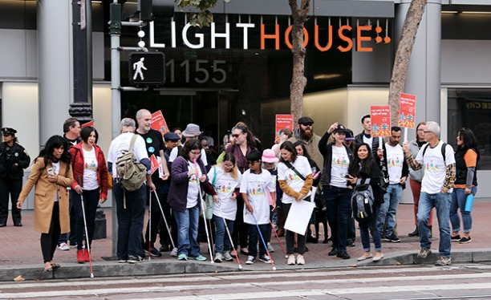
Photo caption: A group of LightHouse staff and supporters gathered outside LightHouse Headquarters in San Francisco on White Cane Day. Photo by Sarika Dagar
With the strength of kind donors and supporters, we are empowering the blind community, designing innovative programs and expanding our reach across California and beyond. Please consider a donation to support LightHouse for the Blind and Enchanted Hills Camp.

To learn more about how you can invest in the LightHouse and Enchanted Hills, please contact our Director of Development Jennifer Sachs at 415.694.7333 or giving@lighthouse-sf.org.

1155 Market Street, Floor 10
San Francisco, CA 94103
Phone: 415-431-1841
VP: 415-255-5906
EIN 94-1415317

Learn more about what we do: www.lighthouse-sf.org
© LightHouse for the Blind and Visually Impaired 2021

